APRIL 20th, 2024

Jack Byrne Arena

Proudly Presents

2024 Ice Show

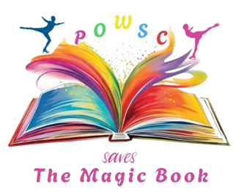

2024 Ice Show
Information Package

Meet The Producers
Viktoriya and Yuriy Vaypan with Allison Dawe

Viktoriya and Yuriy Vaypan, have been in sports since childhood. In 2022, they moved to Canada and are now it’s their second year at POWSC. Yuriy is a figure skating coach, and Viktoriya is the off-ice coach-choreographer.
Before coming to Canada, they worked in Figure skating clubs in Finland and Ukraine, where they organized various ice shows. Prior to our coaching roles, they spent many years participating in different shows – Yuriy in ice shows across Europe and the USA, and Viktoriya in dance shows in Germany and the UK.

Allison is a current official with Skate Canada, skater on an adult synchronized team, board member with POWSC, and a skating mom - but before those roles she was a Skate Canada Professional Coach in Singles, Dance and Synchronized skating for 15 years with CBNSC, PARC SC and CBS SC. Before her early coaching career, she was a competitive Ice Dancer for several years and competed with her partner who was from the POWSC! Also competing in Singles at the provincial level and Synchronized skating for many years up to the National level, she has experience in everything figure skating and will be getting back into coaching soon!

The producers are very excited to contribute to this year’s ice show at POWSC, hoping it will bring many enjoyable moments and unforgettable experiences for all participants.

Ice Show Fee
The fee associated with the Ice Show contributes to your child’s costume, coaching and production fees, ice time, decorations, and any other costs associated with our show.
Show Group Numbers and Soloists
If your child is enrolled in a POWSC program, they have the opportunity to be in our show!
The Opening number includes our Junior, Intermediate, and Senior skaters.
CanSkaters will be in a group based on their level and which of our CanSkate sessions they are enrolled in. (e.g. Jack Byrne or Yetmans, Capital Subaru, Goulds Arena), and their time slot may come into consideration) Once we have finalized who has registered and how many skaters we have, we will look at what the best way to split our CanSkate groups, it is different every year.
Junior, Intermediate, and Senior will each have their own number in the show.
Synchro Teams will also be included in the show and managers will reach out to teams to see if they have enough team members available to take part in the show.
Solos are awarded based on a specific selection criteria. These are our StarSkaters and Competitive Skaters who have competed throughout the season and placed in their category. If time permits small mini group numbers may be considered.
The closing number/Finale includes all skaters who took part in the show for a final bow:)

Show Practices
Our ice shows have to come together very quickly due to our competition season. We usually begin rehearsal 2-3 weeks prior to the date of the show.
Practice times are to be determined after registration has ended and we know how many skaters we have registered at each level, especially CanSkate.
Practice times will be as close to skaters regular practice time as possible.
There is a chance that your child may have to attend a practice at a time outside their regular practice hours, but we do our best to keep it as similar as possible.
Additional Information
Show Day: CanSkaters, and Juniors that cannot tie their skates on their own, will get their skates and costumes on in advance of the show with the help of their parents/guardians. They will be seated, fully dressed, in the audience near the curtain with at least one volunteer chaperone per group to watch the show. They will be escorted to the ice when it is their turn to perform. Parents are asked to pack a snack for their child as well.
Costumes are ordered by us and the cost is included in your ice show fee. They are usually dance costumes so it is very important to provide accurate measurements for your child. If the costume does not fit, it can be difficult for us to get a new one ordered in time for the show.

Some costumes also may be different for boys and girls, we order a costume for your child based on the gender listed on their Skate Canada profile. If your child identifies differently than what their profile shows or would prefer to wear a costume of the opposite gender please let us know as soon as possible. We will accommodate all requests that are received by January 31, 2024.
Registration closes on: Feb 2, 2024 (FIRM – late registrations will NOT be accepted)
Registration Fees – Ice Show
CanSkate - $90.00 (includes costume)
PreSTAR - $90.00 (includes costume)
Junior/Intermediate/Senior - $120.00
Synchronized Skating - $12.00 (no costume needed)
Registration can be done https://powsc.uplifterinc.com/registration/products/
If you have any specific questions regarding the show, please reach out to us! Our email for the ice show is below:

POWSCIceShow2024@gmail.com

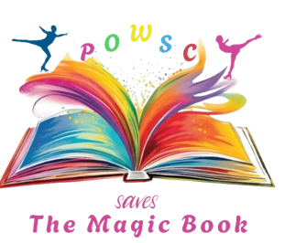

…..Embarking on a magical journey through the captivating pages of fairy tales, each book in our collection unfolds as a separate world, teeming with exciting adventures. These books weave tales that introduce us to the amazing characters and share stories.

Among these books there is one book that is universally cherished from childhood – the Magical book of Fairy Tales, which is a portal to an unforgettable world of magic and miracles. This extraordinary tomb possesses the wondrous ability to transport the readers directly into the heart of the fairy tale they are immersed in.

However, on a fateful evening, as the sun dipped below the horizon, mischievous book monsters crept into our sanctuary, pilfering pages from the magic book scattering them among the different fairy tales.

Now, our vigilant heroes must embark on a quest to recover those lost pages, scattered through the enchanting tales, and reunite them with their rightful place in the magical book.

Come see our show to see how the magical quest unfolds……

